$45,000.00
FAVREAU – GRIFFIS, LYONS
2205 MITCHELL ST. JAVA
JAVA 1ST ADDN TO PAYNE’S PLAT LOTS 3 & 4 BLOCK 5
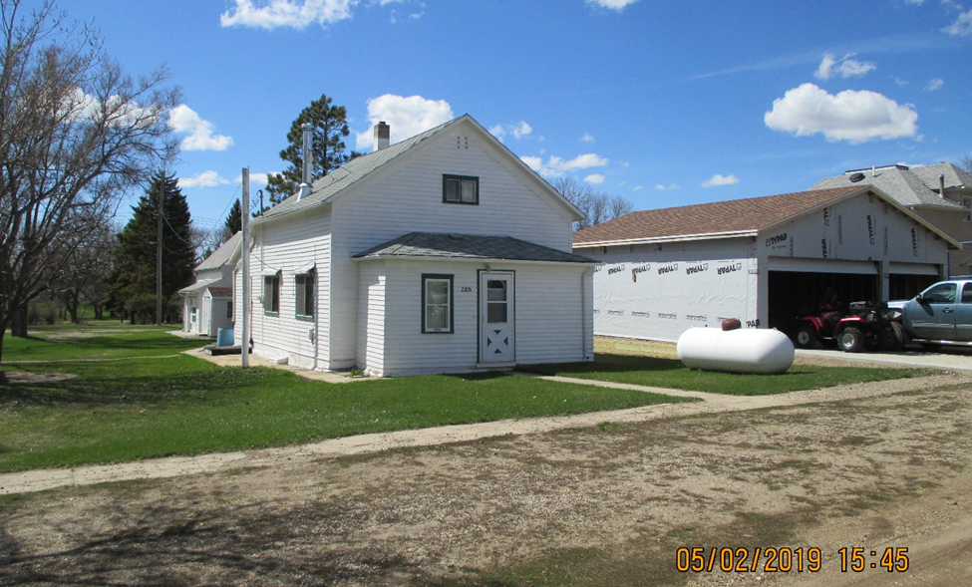
RECORD #4156

LOT SIZE 100’ X 140’ 748 SQ FT MAIN FLOOR
SINGLE FAMILY – ONE STORY 906 SQ FT TOTAL
FINISHED ATTIC NO BSMT
FAIR QUALITY
AVERAGE CONDITION 16’ X 24’ DETACHED GARAGE
BUILT IN 1900 16’ X 18’ SOLID WALL PORCH
SOLD ON 1/15/19 FOR $45,000
ASSESSED IN 2019 AT $9,185
SOLD IN 2011 $15,000
ASSESSED IN 2012 $7,725 RECORD #4156

