$26,000.00
TOREVELL – MAXEY
5011 PACIFIC AVE. JAVA
JAVA MILW LAND CO’S 3RD ADDN LOTS 5 & 6 BLOCK 24
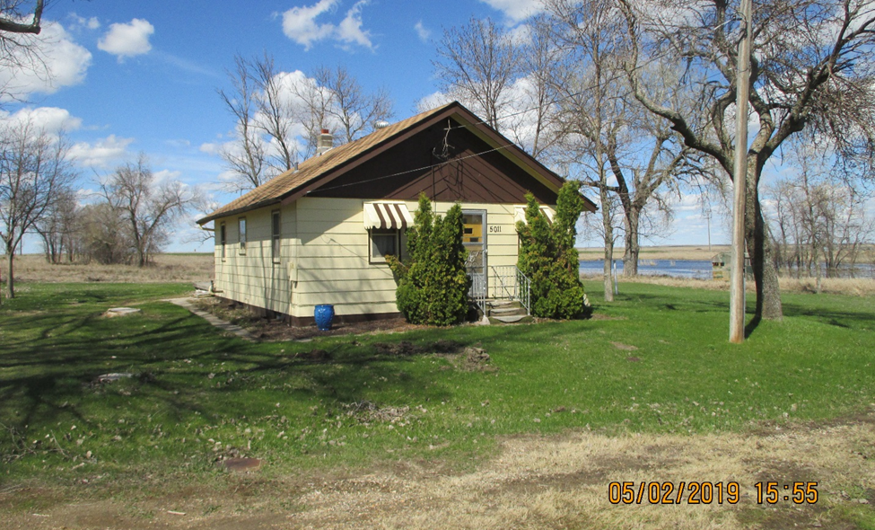
RECORD #4120

LOT SIZE 100’ X 140’ 996 SQ FT GROUND FLOOR
ONE STORY – SINGLE FAMILY 940 SQ FT BSMT/100 SQ FT FIN REC
AVERAGE QUALITY & CONDITION 2 BEDROOMS 1 BATH
BUILT IN 1905 FORCED AIR
SOLD ON 12/17/2018 FOR $26,000 16’ X 26’ DETACHED GARAGE
ASSESSED IN 2019 $8,390
SOLD IN 2017 FOR $19,300
ASSESSED IN 2017 AT $7,630 #4120
SOLD IN 2010 FOR $13,000
ASSESSED IN $5,884

