$180,000.00
JACKSON – SCHAEFER
1311 2ND ST EAST, MOBRIDGE
LOTS 1 & 2 BLOCK 16 EAST MOBRIDGE ADDN NE4 STR 29-124-79
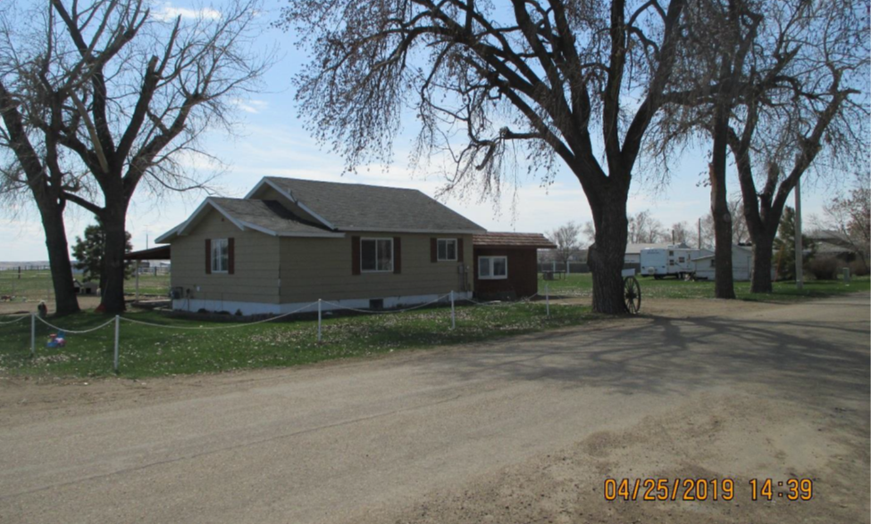
RECORD #3751

LOT SIZE 1 ½ ACRES GROUND FLOOR 1872 SQ FT
SINGLE FAMILY – ONE STORY 3 BEDROOMS 2 BATHS
AVERAGE QUALITY & CONDITION BASEMENT 576 SQ FT FIN LIVING
BUILT IN 1955
SOLD ON 2/5/2019 FOR $180,000
ASSESSED IN 2019 AT $59,915 RECORD #3751
ASSESSED IN 2012 AT $52,100

THIS SALE ALSO INCLUDES RECORD #’S 3752, 3753 &3761. 31 LOTS OR 6.61 ACRES. 3600 SQ FT STORAGE BLDG. GRAIN BINS.1

