$70,000.00
NORBERT ARBACH FAMILY TRUST – FALLING STAR ACRES LLC
STR 28-121-75
LOT 1 ARBACH ADDN SE4SW4 28-121-75
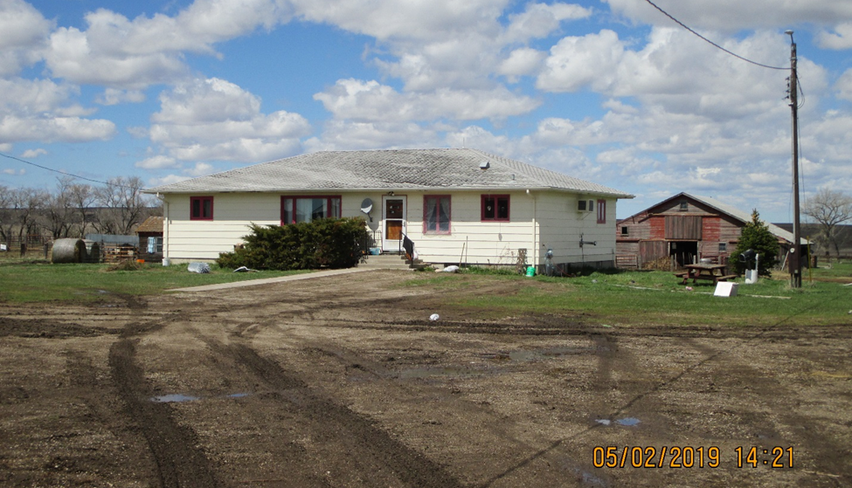
RECORD #315

6.8 ACRES GROUND FLOOR 1800 SQ FT
(WITH ROW 7.06 ACRES) 3 BEDROOMS 2 BATHS
SINGLE FAMILY – ONE STORY BASEMENT 1800 SQ FT NOT FINISHED
FAIR QUALITY & CONDITION SEVERAL AG BLDGS. BARNS, BINS ETC.
BUILT IN 1965
SOLD ON 10/04/2018 FOR $70,000
ASSESSED IN 2019 AT $67,795 RECORD #315
ASSESSED IN 2017 AT $57,795

