$320,000.00
JANSEN-QUENZER
110 20TH ST WEST, MOBRIDGE
ULMER SUBD. BLOCK 2 & VACATED ST BTWN W 379.78 OF E 1826.56’ OF N365.7’ OF 699.55’ & ULMER SUBD BLOCK 2
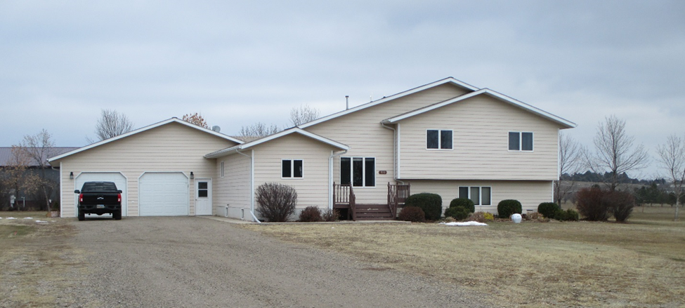
RECORD #7543

2.07 ACRES GROUND FLOOR 1832 SQ FT
SPLIT LEVEL- SINGLE FAMILY 3 BEDROOMS
AVERAGE QUALITY & CONDITION 2 ½ BATHS
BUILT IN 1997 ATTACHED GARAGE 784 SQ FT
NATURAL GAS – CENTRAL AIR WOOD DECK 216 SQ FT
1999 MOVED 34’X48’ BUILDING TO SITE
SOLD ON 8/14/18 FOR $320,000
ASSESSED IN 2018 AT $219,530
SOLD IN 2014 FOR $273,000
ASSESSED IN 2012 AT $141,390 RECORD #7543
ASSESSED IN 2015 $162,600

