$1,300,000.00
SELBY DEVELOPMENT – AG DAKOTA LLC
SD HWY 12 & 83, SELBY
SELBY MOTEL – CHS ADDN TO CITY OF SELBY IN SE4 32-124-76
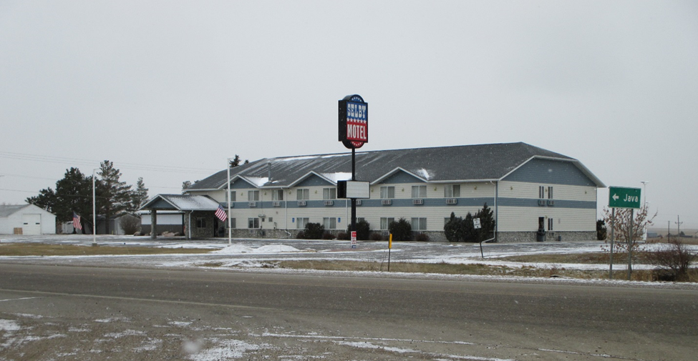
RECORD #7450

LOT SIZE 2.71 ACRES
100% COMMERCIAL
MOTEL – RESTAURANT
2 STORIES
BUILDING 56’ X 134’
AVERAGE QUALITY & CONDITION
2016 NEW ADDN RESTAURANT/LOUNGE 2050 SQ FT
SOLD ON 9/5/18 FOR $1,300,000
ASSESSED IN 2018 AT $357,015
ASSESSED IN 2014 AT $317,015
BUILT IN 1996 RECORD #7450

