$12,500.00
NORDER-LANGNER
611 EAST GRAND CROSSING, MOBRIDGE
FISHERMAN’S CONDO
MOBRIDGE RINEHART’S ADDN FISHERMAN’S CONDO LOTS 1 THRU 11
UNIT #5 BLOCK 1
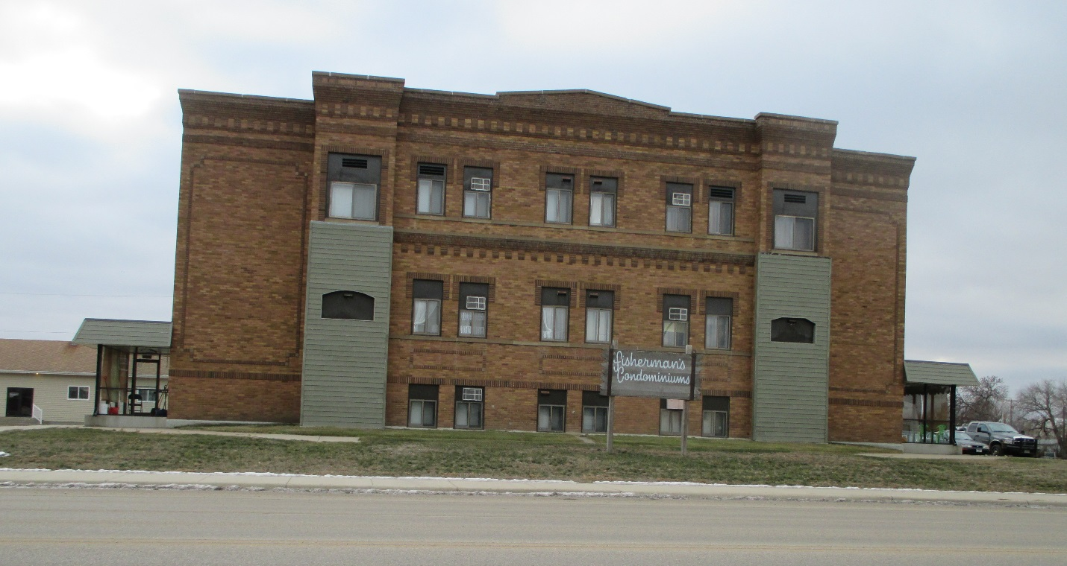
RECORD #6369

CONDOMINIUM 325 SQ FT
AVERAGE QUALITY 1 BEDROOM
AVERAGE CONDITION 1 FULL BATH
ELECTRIC HEAT
WINDOW AIR
BUILDING IS BRICK, FLAT ROOF
BUILT IN 1930
SOLD ON 8/7/18 FOR $12,500, SOLD IN 2015 FOR $12,500
ASSESSED IN 2018 AT $9,800, ASSESSED IN 2015 AT $9,800

