$95,000.00
VOLLER – HOLZER
714 1ST AVE EAST, MOBRIDGE
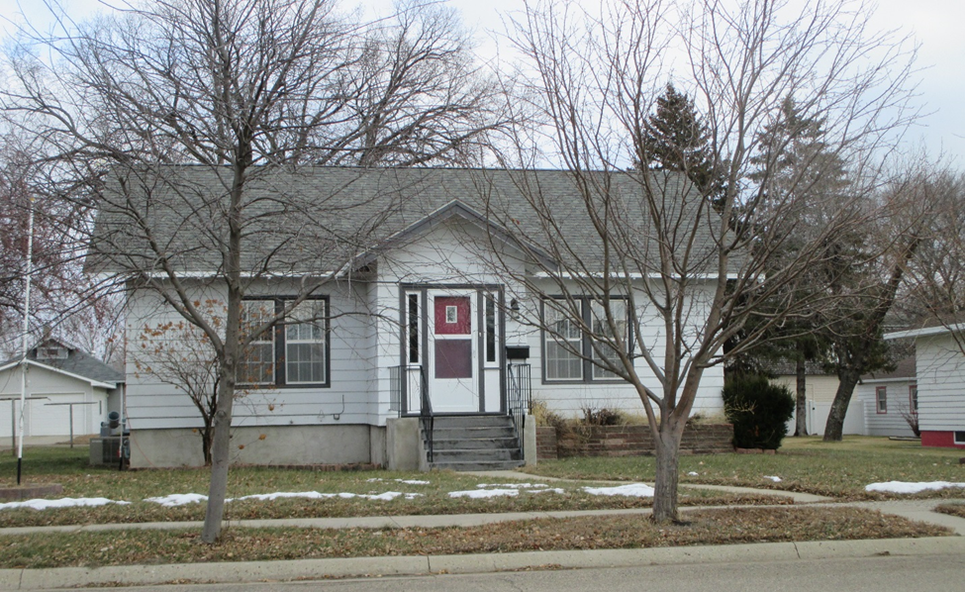
MOBRIDGE GRAND CROSSING ADDN N 10’ OF LOT 9 ALL OF LOT 10 BLOCK 60

LOT SIZE 60’ X 140’ GROUND FLOOR 1100 SQ FT
SINGLE FAMILY – ONE STORY 2 BEDROOMS 2 ½ BATHS
AVERAGE QUALITY & CONDITION BASEMENT 900 SQ FT FIN. REC.
BUILT IN 1930 ATTACHED GARAGE 11’ X 24’
2014; ROOF GOOD, WINDOWS POOR DETACHED GARAGE 28’ X 32’
SPRINKLER SYSTEM, NATURAL GAS 11’ X 15’ COVERED WOOD DECK
CENTRAL AIR 6’ X 8’ SOLID WALL PORCH
SOLD ON 10/10/18 FOR $95,000
ASSESSED IN 2018 $74,230
SOLD IN 2008 FOR $68,000
ASSESSED IN 2013 AT $ 48,285 RECORD #5467

