$93,000.00
IMBERI – CONLON
322 6TH ST WEST, MOBRIDGE
MOBRIDGE GRAND CROSSING ADDN LOT 7A BLOCK 47
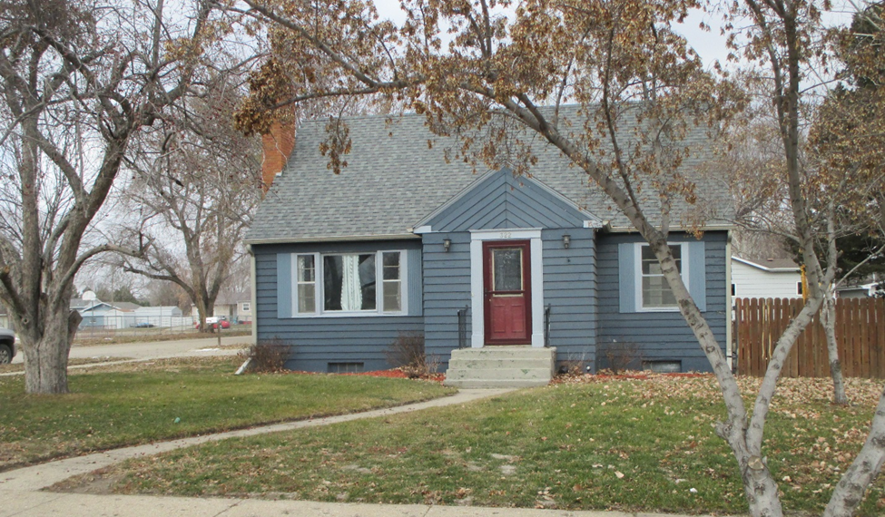
RECORD #5363

LOT SIZE 70’ X 150’ MAIN FLOOR 884 SQ FT
SINGLE FAMILY 1 ½ STORY TOTAL LIVING 1149 SQ FT
AVERAGE QUALITY & CONDITION BASEMENT 884 SQ FT NO FINISH
BUILT IN 1950 2 BEDROOMS 2 ½ BATHS
CENTRAL AIR - NATURAL GAS 18’ X 24’ ATTACHED GARAGE
2014; WOOD SIDING POOR, ROOF GOOD 5’ X 11’ SOLID WALL PORCH
WINDOWS FAIR, DORMER ON NORTH
DECK ON TOP OF GARAGE, BRICK FIREPLACE
SOLD ON 10/19/18 FOR $93,000
ASSESSED IN 2018 AT $78,870 RECORD #5363
SOLD IN 2012 FOR $75,500
ASSESSED IN 2014 AT $78.265

