$25,000.00
SALVERSON – SILVERNAGEL
216 7TH AVE EAST, MOBRIDGE
MOBRIDGE EKLO’S 3RD ADDN W 110’ OF LOT 31
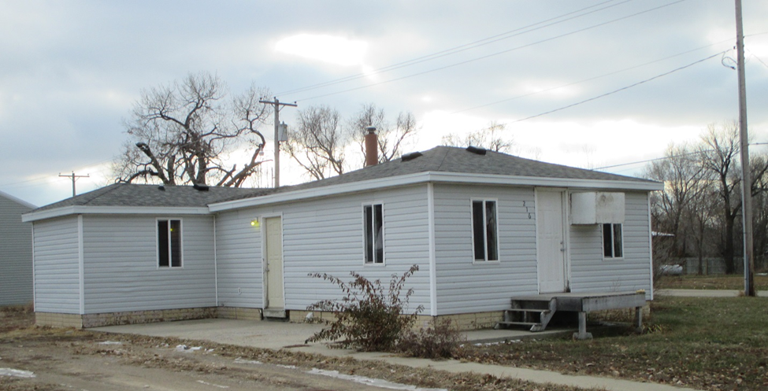
RECORD #5056

LOT SIZE 105.8’ X 120’ TOTAL LIVING 805 SQ FT
FAIR QUALITY & CONDITION 1 BEDROOM 1 ½ BATH
ONE STORY SINGLE FAMILY 10’ X 12’ UTILITY SHED
BUILT IN 1920 CONCRETE SLAB PATIO
1984 RESIDED HOUSE WINDOW AIR
2014 NEW WINDOWS PROPANE HEAT
SOLD ON 10/12/18 FOR $25,000
ASSESSED IN 2018 AT $27,000
SOLD IN 2013 FOR $27,500
ASSESSED IN 2013 AT $11,230 RECORD #5056

