$23,000.00
VETTER – SCANNIELLO
4711 1st AVE, SELBY
SELBY OVERHOLSERS ADDN LOT 12 BLOCK 2
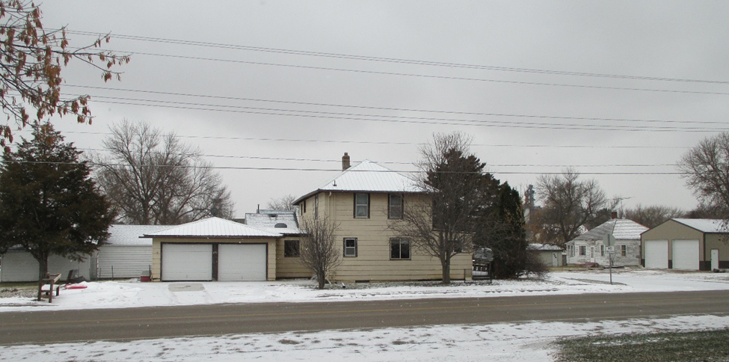
RECORD #4550

LOT SIZE 50’ X 140’ GROUND FLOOR 960 SQ FT
2 STORY SINGLE FAMILY 2ND FLOOR 704 SQ FT
AVERAGE QUALITY & CONDITION 3 BEDROOMS 2ND FLOOR
BUILT IN 1916 + - MOVED IN 1964 1 BEDROOM GROUND FLOOR
NATURAL GAS CENTRAL AIR 2 FULL BATHS
2015; MASONITE POOR, WINDOWS POOR BASEMENT 704 SQ FT
SOLD ON 7/25/18 FOR $23,000 ATTACHED 2 STALL GARAGE
ASSESSED IN 2018 AT $40,270 280 SQ FT WOOD DECK
SOLD IN 2015 FOR $40,000 64 SQ FT SOLID WALL PORCH
ASSESSED IN 2014 AT $42,595
RECORD #4550

