$2,500.00
FEES – SIMPSON
3406 CHICAGO, JAVA
JAVA MILW LAND CO’S 2ND ADDN LOTS 7,8,9, & S½ OF 10 BLOCK 12
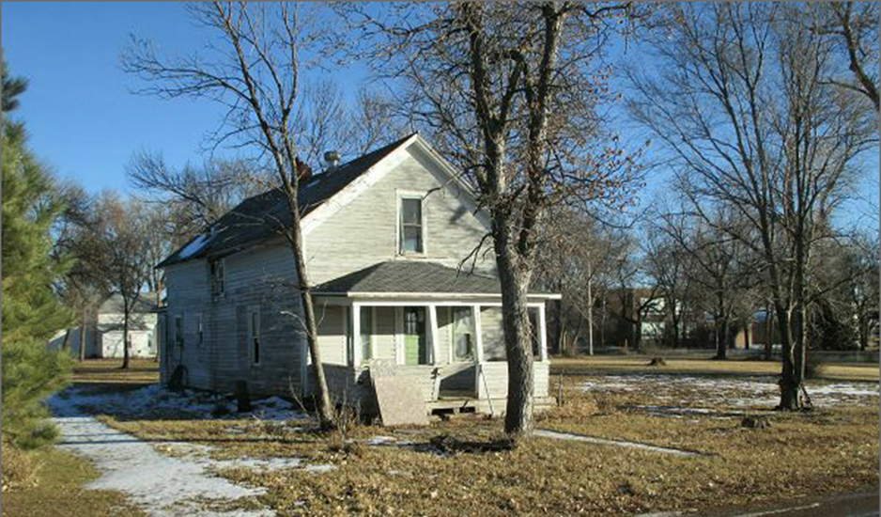
RECORD #4071

LOT SIZE 175’ X 140’
SINGLE FAMILY 1 ½ STORY
POOR CONDITION & QUALITY
BUILT IN 1900 + -
GROUND FLOOR 612 SQ FT
TOTAL 918 SQ FT
NO BASEMENT
BADLY WORN

