$22,000.00
KOPRIVA – SCANNIELLO
3911 OVERHOLSER, SELBY
SELBY OVERHOLSER ADDN LOT 1 OF TRACT 2 OUTLOT A
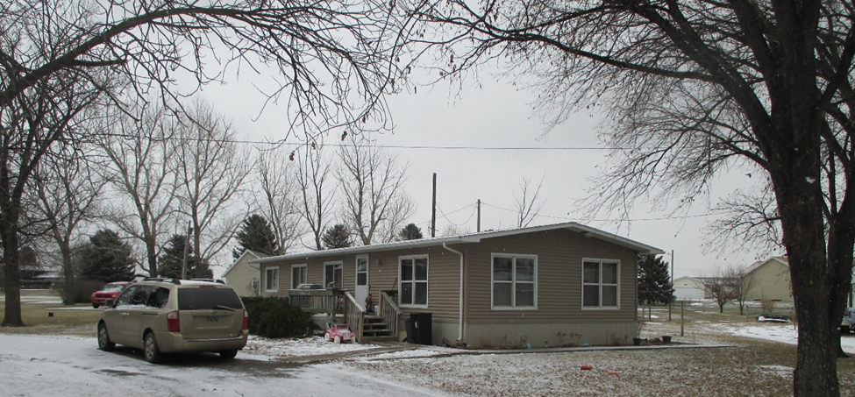
RECORD #4600

LOT SIZE 115’ X 168’ LIVING AREA 1311 SQ FT
& 20’ X 168’ 3 BEDROOMS, 2 FULL BATHS
MANUFACTURED HOME WOOD DECK 128 SQ FT
AVERAGE QUALITY & CONDITION OPEN SLAB PORCH 104 SQ FT
BUILT IN 1974
2015; ROOF FAIR, CENRAL AIR
NATURAL GAS, 2011 NEW SHINGLES
SOLD ON 6/8/2018 FOR $22,000
ASSESSED IN 2018 AT $21,500 RECORD #4660
SOLD IN 2017 FOR $23,000
ASSESSED IN 2017 AT $21,500
ASSESSED IN 2013 AT $25,085

