$79,000.00
RAU – LARSON
5206 5TH AVE, SELBY
SELBY MILW LAND CO’S 2ND ADDN LOT 2 EXC. E 93.4’ OF N 30’ & EXC. W 46.8’ OF N 40’ & ALL LOT 3 BLOCK 26
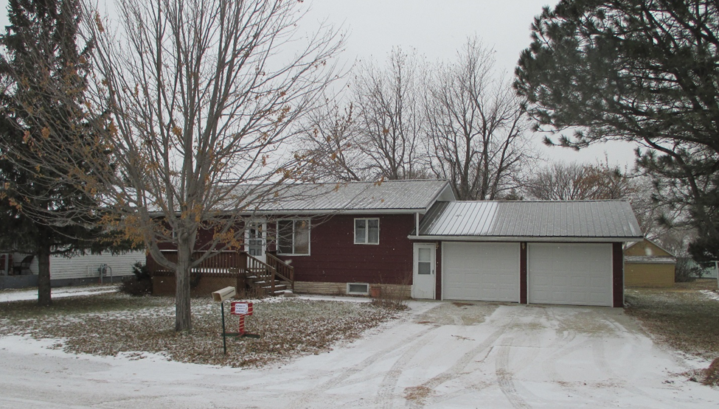
RECORD #4346

LOT SIZE 60’ X 140’ GROUND FLOOR 1120 SQ FT
& 10’ X 93.4’ BASEMENT 1120 SQ FT
SINGLE FAMILY ONE STORY 2 BEDROOMS GROUND FLOOR
AVERAGE QUALITY & CONDITION 2 BEDROOMS BASEMENT
BUILT IN 1980 1 FULL BATH GROUND FLOOR
2018; METAL ROOF ¾ BATH BASEMENT
SOLD ON 9/17/18 FOR $79,000 ATTACHED 2 STALL GARAGE
ASSESSED IN 2018 AT $130,440 120 SQ FT WOOD DECK FRONT
SOLD IN 2011 FOR $80,000 120 SQ FT WOOD DECK BACK
ASSESSED IN 2015 AT $73,025 196 SQ FT OPEN SLAB PORCH

