$20,000.00
NORDER-WAGNER
FISHERMAN’S CONDO, GRAND CROSSING, MOBRIDGE
MOBRDIGE RINEHART’S ADDN FISHERMAN’S CONDO UNIT #9
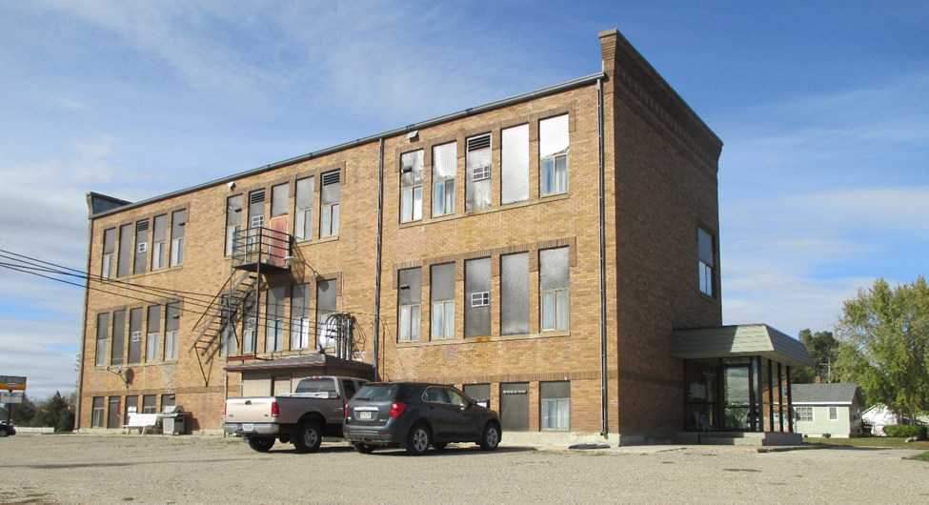
RECORD #6373

CONDOMINIUM BUILT IN 1935
612 SQ FT
1 BEDROOM
1 BATH, 5 FIXTURES
SOLD ON 7/24/18
ASSESSED IN 2018 AT $17,490
SOLD IN 2013 AT $18,750
ASSESSED IN 2012 AT $17,490 RECORD #6373

