$225,000.00
TRUAX-WIENTJES
1020 10TH ST WEST, MOBRIDGE
MOBRIDGE NWTS CO’S 3RD ADDN S 20’ OF LOT 4 & ALL LOTS 5 & 6 BLOCK 27
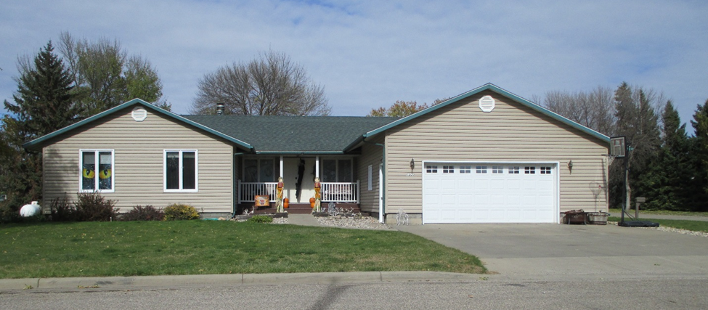
RECORD #6116

LOT SIZE 120’ X 120’ GROUND FLOOR 1776 SQ FT
SINGLE FAMILY ONE STORY 3 BEDROOMS 3 ½ BATHS
AVERAGE CONDITION & QUALITY BASEMENT 1776 SQ FT
BUILT IN 1979 535 SQ FT FINISHED LIVING
2014; ROOF GOOD, VINYL SIDING ATTACHED GARAGE 728 SQ FT
WINDOWS FAIR, SPRINKLER SYSTEM ROOFED PORCH 126 SQ FT
CENTRAL AIR, BLOCK FOUNDATION WOOD DECK 168 SQ FT
SOLD ON 6/12/18 FOR $225,000
ASSESSED IN 2018 AT $197,070
ASSESSED IN 2012 AT $132,345

