$165,000.00
LEPKE-OLSON
1122 3RD AVE WEST, MOBRIDGE
MOBRIDGE NWTS CO’S 2ND ADDN N32’ OF LOT 15 & LOT 16 BLOCK 16
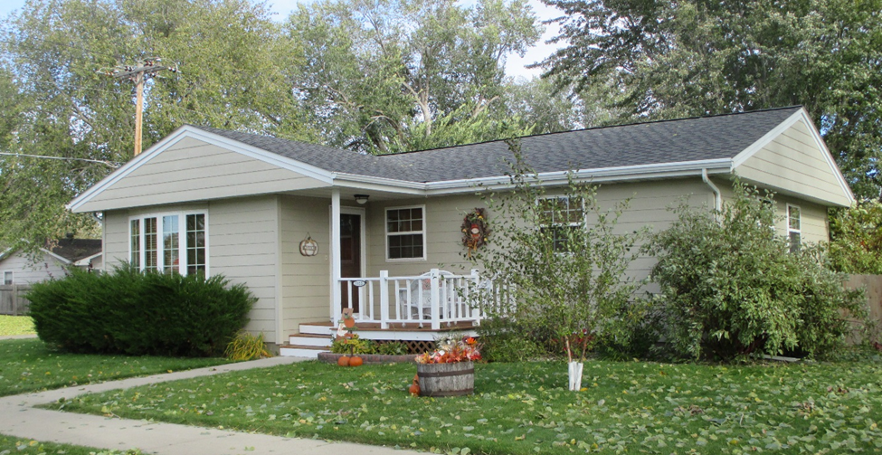
RECORD #6021

LOT SIZE 78’ X 140’ TOTAL LIVING AREA 1040 SQ FT
SINGLE FAMILY 1 STORY 3 BEDROOMS 1 ½ BATHS
AVERAGE QUALITY & CONDITION BASEMENT 1040 SQ FT
BUILT IN 1965 900 SQ FT FIN. REC.
2014; ROOF FAIR, WINDOWS GOOD DETACHED GARAGE
CEMENT BOARD SIDING, CENTRAL AIR SLAB PATIO 288 SQ FT
EGRESS WINDOW SOUTH WOOD DECK IN FRONT 88 SQ FT
SOLD ON 8/3/18 FOR $165,000
ASSESSED IN 2018 AT $125,770
SOLD IN 2016 FOR $150,000; 1991 FOR $42,500
ASSESSED IN 2016 AT $114,370; 2012 AT $55,040 RECORD #6021

