$225,000.00
BANIK-BOLDUAN
1017 3RD AVE WEST
MOBRIDGE NWTS 1ST ADDN S 28’ OF LOT 3 & ALL LOT 4 BLOCK 2
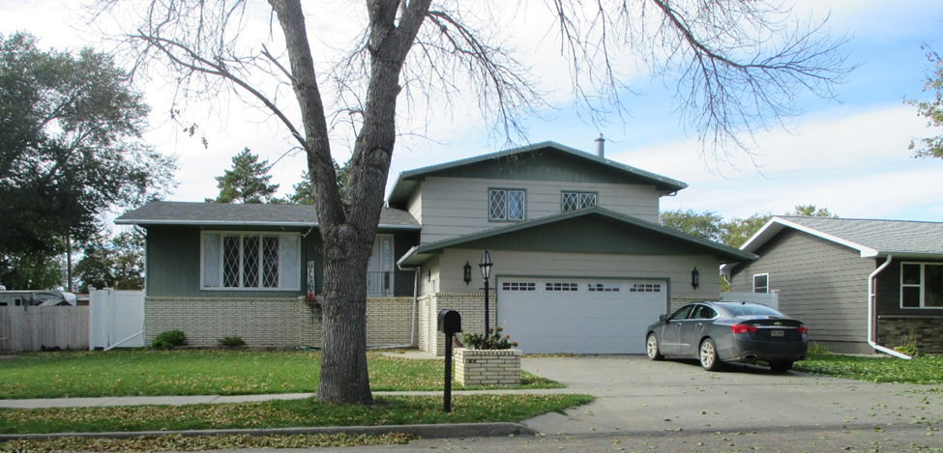
RECORD #5913

LOT SIZE 68 X 140’ GROUND FLOOR 1214 SQ FT
SINGLE FAMILY SPLIT LEVEL TOTAL LIVING AREA 1656 SQ FT
AVERAGE QUALITY & CONDITION 3 BEDROOMS ABOVE 1 BELOW
BUILT IN 1978 2 FULL BATHS AND A ½ BATH
2014; REMODEL KITCHEN & BATH CENTRAL AIR NATURAL GAS
NEW CABINETS, FLOORING, CABINETS BASEMENT TOTALLY FINISHED
COUNTERTOPS: $40,000 ATTACHED GARAGE 702 SQ FT
SOLD ON 8/29/18 FOR $225,000 DETACHED GARAGE 832 SQ FT
ASSESSED IN 2018 AT $187,170 WOOD DECK 126 SQ FT
SOLD IN 2010 FOR $145,000 ROOFED PORCH 48 SQ FT
ASSESSED IN 2012 AT $107,216
RECORD #5913

