$43,000.00
RINGLER-HUBER
808 1ST AVE EAST, MOBRIDGE
MOBRIDGE MAIN PARK LOT 12 BLOCK 12
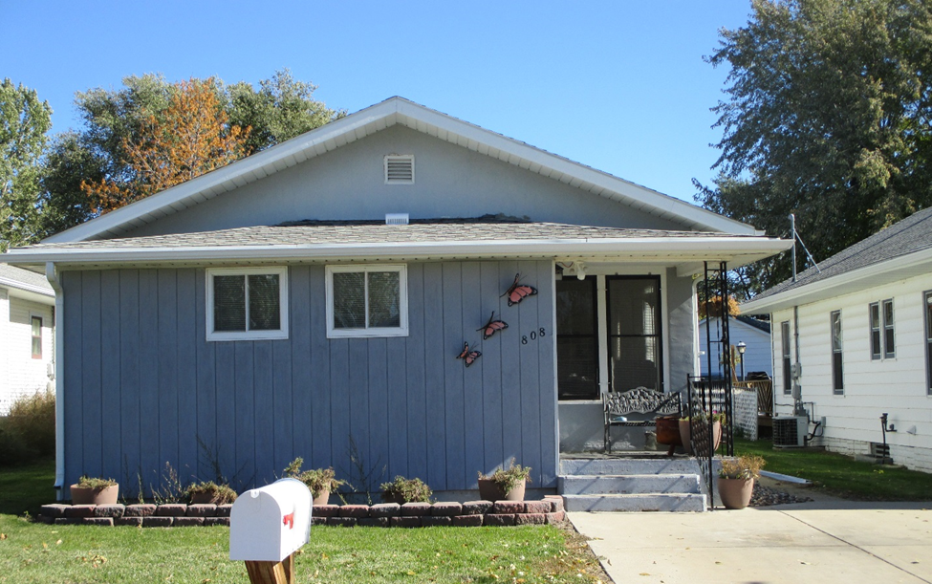
RECORD #5623

LOT SIZE 37.5’ X 142’ GROUND FLOOR 920 SQ FT
SINGLE FAMILY ONE STORY 2 BEDROOMS ONE FULL BATH
AVERAGE QUALITY & CONDITION ONE ½ BATH, SHOWER STALL
BUILT IN 1920 BASEMENT 912 SQ FT
2014; SOME NEW WINDOWS DETACHED GARAGE 216 SQ FT
CASEMENT WINDOWS FAIR ROOFED PORCH 56 SQ FT
NATURAL GAS CENTRAL AIR SOLID WALL PORCH 262 SQ FT
SOLD ON 9/12/18 FOR $43,000 OPEN SLAB PORCH 140 SQ FT
ASSESSED IN 2018 AT $54,040
SOLD IN 2013 FOR $50,000
ASSESSED IN 2012 AT $34,940 RECORD #5623

