$95,000.00
MILLER-ROESLER
604 3RD AVE EAST, MOBRIDGE
MOBRIDGE GRAND CROSSING ADDN N 10’ OF LOT 4E & ALL OF LOT 4F BLOCK 61
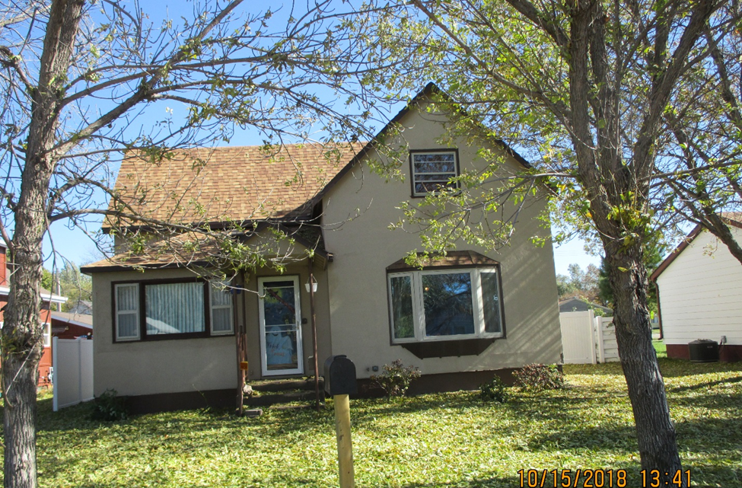
RECORD #5487

LOT SIZE 53’ X 140’ GROUND AREA 928 SQ FT
SINGLE FAMILY 1 ½ STORY TOTAL AREA 1232 SQ FT
AVERAGE QUALITY & CONDITION 3 BEDROOMS ABOVE
BUILT IN 1910 1 BEDROOM BELOW
2014; STUCCO, ROOF GOOD, WINDOW GOOD 1 BATH 5 FIXTURES
NATURAL GAS, FOUNDATION FAIR DETACHED GARAGE 1936 SQ FT
1994; 32’ X 48’ GARAGE KNEE WALL PORCH 96 SQ FT
1998; 8 X 48 ADDN TO GARAGE OPEN SLAB PORCH 336 SQ FT
SOLD ON 6/13/18 FOR $95,000 SOLD ON 2006 FOR $65,000
ASSESSED IN 2018 AT $87,790 ASSESSED IN 2012 FOR $35,575

