$66,333.00
PRUSHA- RUSTAD
613 5TH AVE WEST, MOBRIDGE
MOBRIDGE GRAND CROSSING ADDN LOT 1 & N 10’ LOT 2 BLOCK 50
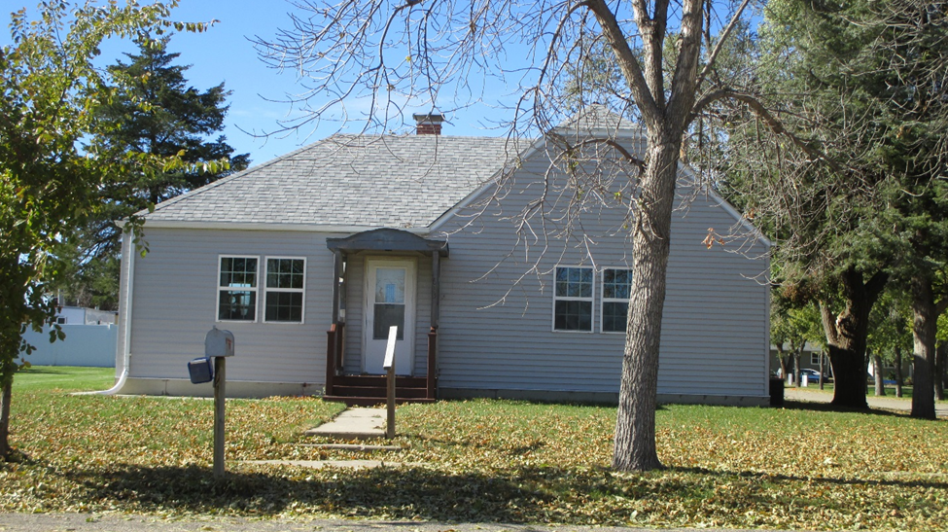
RECORD #5379

LOT SIZE 60’ X 140’ TOTAL LIVING AREA 836 SQ FT
SINGLE FAMILY 1 STORY 2 BEDROOMS 1 ½ BATHS
AVERAGE QUALITY & CONDITION NO BASEMENT
BUILT IN 1930 12’ X 20’ DETACHED GARAGE
1965 REMODEL 18’ X 24’ ATTACHED GARAGE
2014; ROOF GOOD, WINDOWS GOOD 14’ X 12’ UTILITY SHED
SOLD ON 8/16/18 FOR $66,333
ASSESSED IN 2018 AT $50,220, IN 2012 AT $24,475
SOLD IN 2012 FOR $40,000, IN 2005 FOR $37,000 RECORD #5379

