$37,000.00
LINDSKOV-GOSCH
702 5TH AVE EAST
MOBRIDGE FAIRVIEW ADDN E 85’ OF LOT 1 E 85’ OF N 14 ½ ‘ OF LOT 2 BLOCK 13
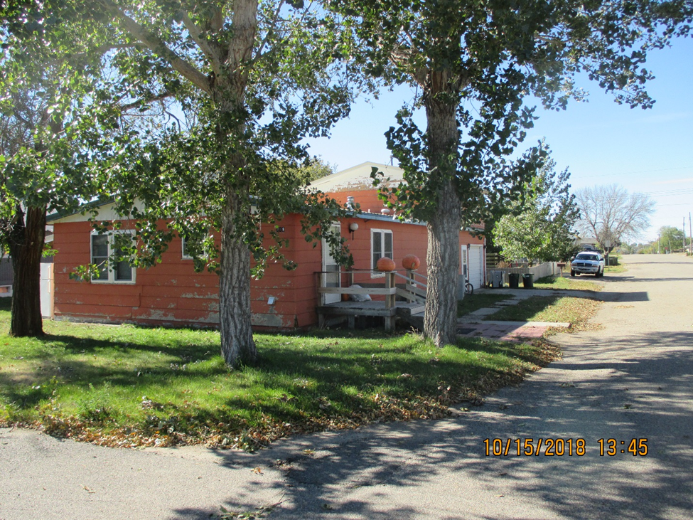
RECORD #5080

LOT SIZE 52’ X 85’ TOTAL LIVING AREA 1560 SQ FT
SINGLE FAMILY ONE STORY 3 BEDROOMS 1 ½ BATHS
FAIR CONDITION & QUALITY TUCK UNDER GARAGE 416 SQ FT
BUILT IN 1960 LIVING QUARTERS ABOVE GARAGE
2014; METAL ROOF, SIDING POOR 10’ X 10’ UTILITY SHED
CENTRAL AIR, NATURAL GAS ROOFED PORCH 220 SQ FT
SOLD ON 9/12/18 FOR $37,00
ASSESSED IN 2018 AT $28,000 ASSESSED IN 2012 AT $29,030

