$77,500.00
BILLINGS-BUESCHER
5 7TH AVE EAST, MOBRIDGE
MOBRIDGE EKLO’S 3RD ADDN LOT 16A
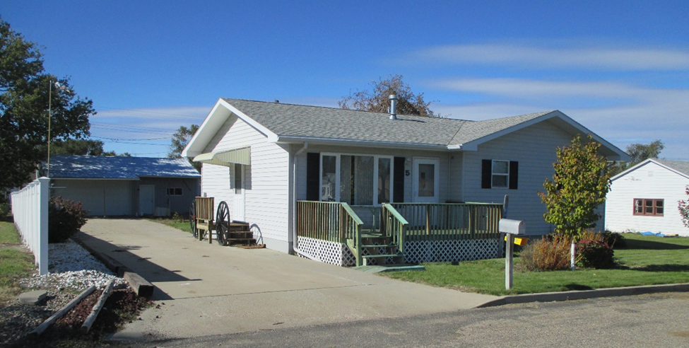
RECORD #5021

LOT SIZE 46.6’ X 150’ TOTAL LIVING AREA 1080 SQ FT
SINGLE FAMILY ONE STORY 2 BEDROOMS, 1 ½ BATH
AVERAGE QUALITY & CONDITION 24’ X 34’ DETACHED GARAGE
BUILT IN 2002 NATURAL GAS CENTRAL AIR
SOLD ON 9/20/18 FOR $77,500
ASSESSED IN 2018 AT $67,180
ASSESSED IN 2012 AT $91,065 RECORD #5021

