$154,000.00
JUNGWIRTH-SCHMIDT
1306 PARK LANE AVE, MOBRIDGE
MOBRIDGE BEL AIRE 2ND ADDN 1ST SUBD LOTS 22 & 23 BLOCK 1 &
N 50’ OF LOT 24 IN BEL AIRE ADDN BLOCK 1
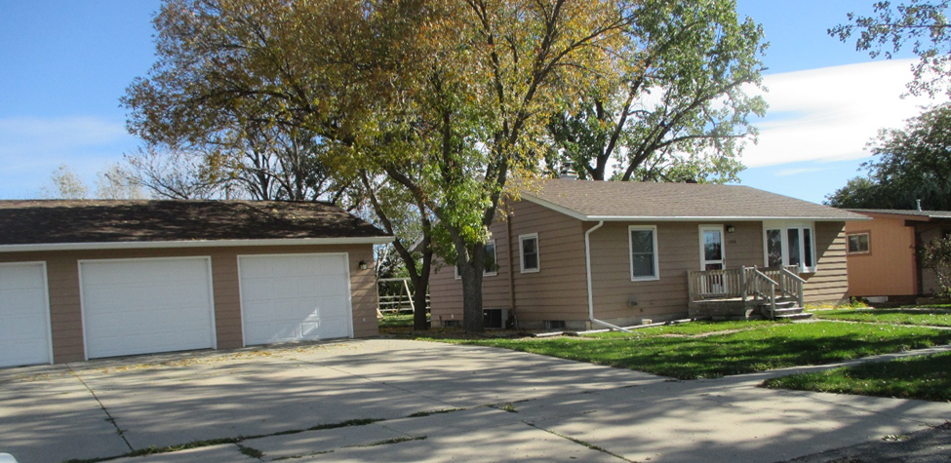
RECORD #4726

LOT SIZE 120’X125’ & 50’X125’ TOTAL LIVING AREA 1008 SQ FT
SINGLE FAMILY 1 STORY 2 BEDROOMS ABOVE
AVERAGE QUALITY & CONDITION 1 BEDROOM BASEMENT
BUILT IN 1963 2 FULL BATHS
2009; 2 EGRESS WINDOWS FURNISHED BASEMENT
2014; ROOF GOOD, SIDING FAIR CENTRAL AIR NATURAL GAS
SOLD ON 9/7/18 FOR $154,000 DETACHED 3 STALL GARAGE 93 SQ FT
ASSESSED IN 2018 $123,940, IN 2012 $85,860 WOOD DECK 168 SQ FT
SOLD IN2004 FOR $75,000 RECORD #4726

