$290,000.00
GOODALE-DIENERT
1011 10TH AVE WEST, MOBRIDGE
MOBRIDGE ACADEMY LOT 3 BLOCK 5
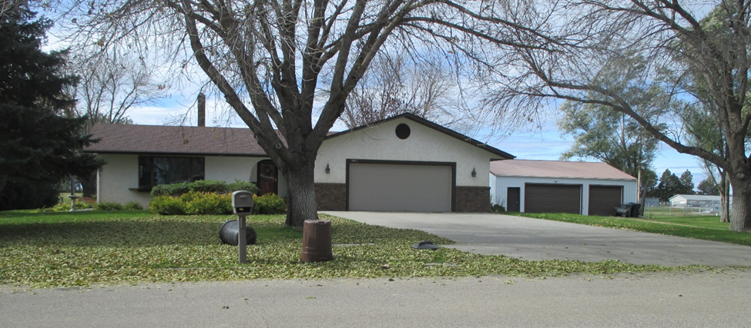
RECORD #4692

LOT SIZE 90’ X 150’ GROUND FLOOR 1704 SQ FT
SINGLE FAMILY ONE STORY 3 BEDROOMS ABOVE 1 BELOW
AVERAGE QUALITY & CONDITION 1 FULL BATH 2 ¾ ‘S BATHS
BUILT IN 1986 BASEMENT 1704 SQ FT
NATURAL GAS CENTRAL AIR 1400 SQ FT FINISHED REC BSMT.
SOLD ON 8/9/18 FOR $290,000 ATTACHED GARAGE 672 SQ FT
ASSESSED IN 2018 AT $237,420 DETACHED GARAGE 1200 SQ FT
ASSESSED IN 2012 AT $146,760

RECORD #’S 4693 & 4692

