$18,000.00
LANG-MERKEL
620 12TH ST EAST, MOBRIDGE
BERG’S LOT B OF LOT 1A OF S2S2SW4NW4 20-124-79
1972 14’ X 68’ NORTHERN AIRE CENTURION
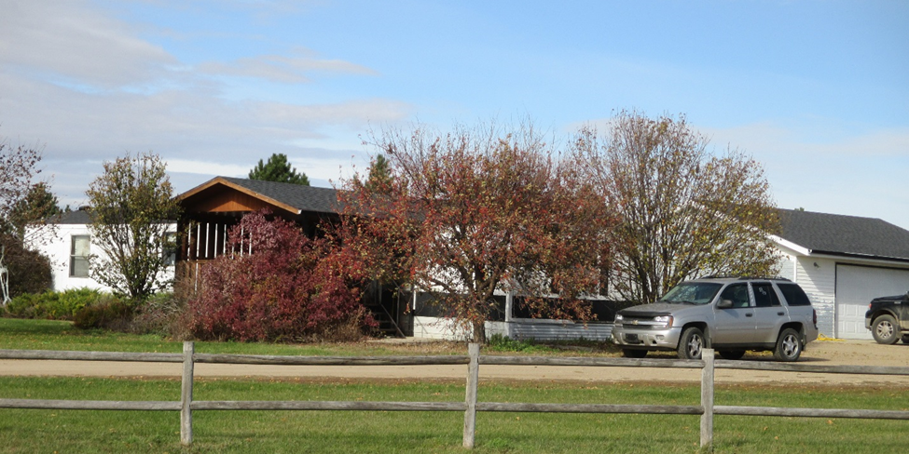
RECORD #3583

LOT SIZE .29 ACRES 3 BEDROOMS
MANUFACTURED HOME 1 FULL BATH
1972 14’X68’ NORTHERN AIRE CENTURION
2015; NEW ROOF ON MOBILE HOME 24’ X 22’ ATTACHED GARAGE
SOLD ON 7/12/18 FOR $18,000 12’ X 16’ WOOD DECK
ASSESSED IN 2018 AT $16,850
SOLD IN 2013 FOR $25,000
ASSESSED IN 2012 AT $11,985 RECORD #3583

