$116,600.00
LARSON FAMILY TRUST-SALUM
1315 NORTH MAIN, MOBRIDGE
MOBRIDGE THOMPSON’S OUTLOTS S ½ OF LOT 18C & ALL OF 18D
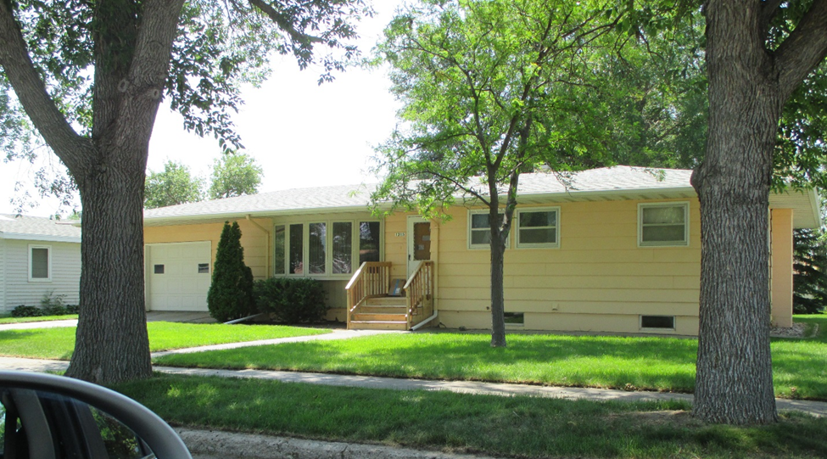
RECORD #6498

LOT SIZE 75’ X 150’ GROUND FLOOR 1348 SQ FT
ONE STORY SINGLE FAMILY BASEMENT 1348 SQ FT
AVERAGE QUALITY & CONDITION BASEMENT 500 SQ FT FIN REC
BUILT IN 1960 3 BEDROOMS ABOVE 1 BELOW
2015; ROOF GOOD, CENTRAL AIR ¾ BATH ABOVE, ¾ BATH BELOW
WOOD DECK WEST, SLAB ON WEST ATTACHED GARAGE 400 SQ FT
LARGE BOW WINDOW WEST WOOD DECK 196 SQ FT
SOLD ON 3/8/18 FOR $116,000 NATURAL GAS
ASSESSED IN 2018 AT $124,750
ASSESSED IN 2012 AT $53,540 RECORD #6498

