$95,000.00
TYLER-LARSON
401 2ND ST EAST, MOBRIDGE
MOBRIDGE-MILW LAND CO’S 2ND ADDN LOT 12 BLOCK 30
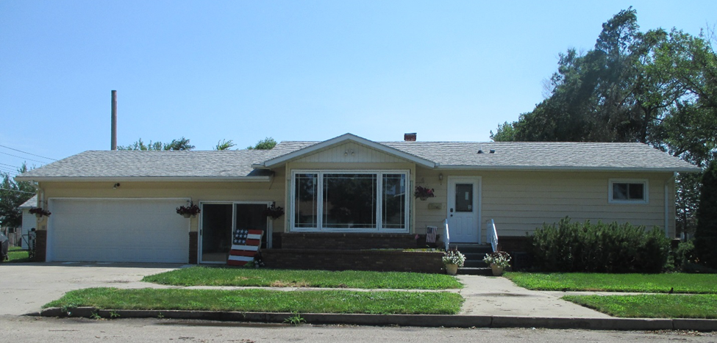
RECORD #5900

LOT SIZE 50’ X 140’ GROUND FLOOR 1051 SQ FT
SINGLE FAMILY ONE STORY BASEMENT 1025 SQ FT
AVERAGE QUALITY & CONDITION BSMT,768 SQ FT FINISHED REC
BUILT IN 1956 2 BEDROOMS ABOVE 1 BELOW
2014; ALUM. SIDING, ROOF FAIR 2 FULL BATHS, ONE HALF BATH
EGRESS ON WEST & SOUTH NATURAL GAS CENTRAL AIR
WINDOWS GOOD ATTACHED GARAGE 562 SQ FT
SOLD ON 1/24/18 FOR $95,000 10’ X 10’ UTILITY SHED
ASSESSED IN 2018 AT $58,460 STEEL SIDING, SPRINKLER SYSTEM
SOLD IN 2012 FOR $58,000
ASSESSED IN 2012 AT $49,780 RECORD #5900

