$6,500.00
STIMES-O’CULL
421 2ND AVE WEST, MOBRIDGE
MOBRIDGE-MILW LAND CO’S 1ST ADDN, LOT 1 BLOCK 24
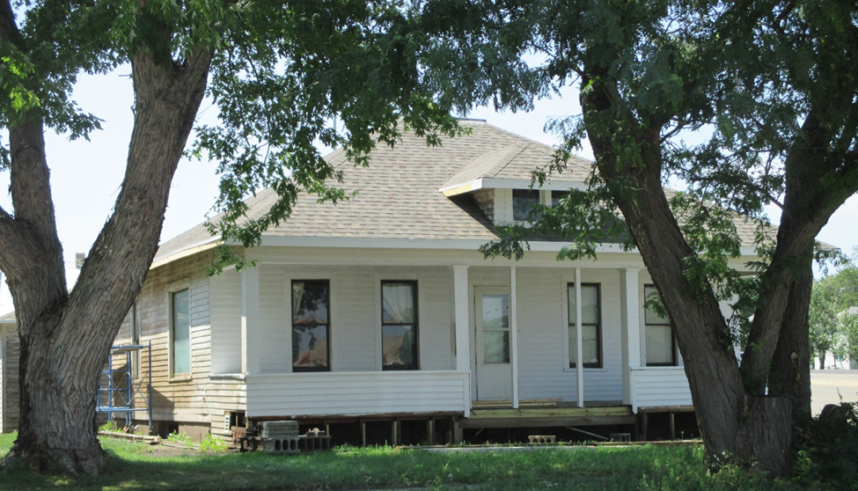
RECORD #5823

LOT SIZE 140’ X 50’ GROUND FLOOR 990 SQ FT
SINGLE FAMILY-ONE STORY 2 BEDROOMS ABOVE ONE BELOW
AVERAGE CONDITION & QUALITY BASEMENT 918 SQ FT
BUIL IN 1915 BASEMENT 459 SQ FT FIN REC
SOLD ON 4/18/18 FOR $6,500 DETACHED GARAGE 352 SQ FT
ASSESSE IN 2018 AT $11,060 238 SQ FT COVERED WOOD PORCH
ASSESSED IN 2012 AT $5,942

RECORD #5823

