$150,000.00
JACQOUT-LEONARD-LUCEK
521 1ST AVE WEST, MOBRIDGE
MOBRIDGE GRAND CROSSING ADDN LOT 1 & 2A BLOCK 40
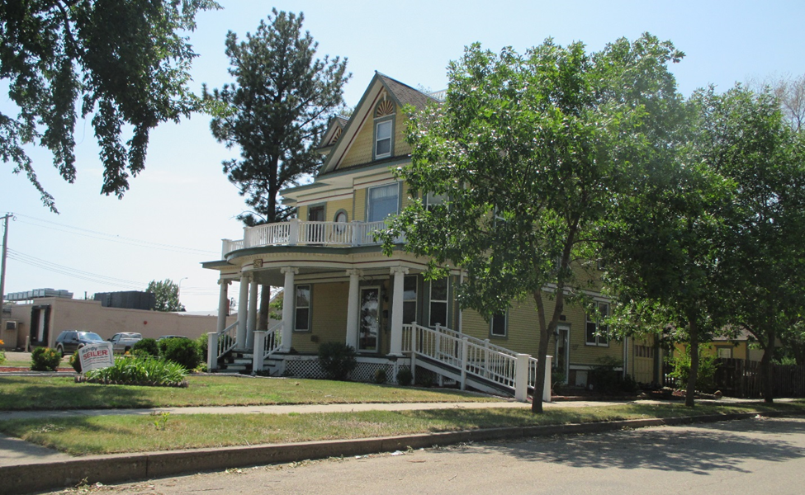
RECORD #5317

LOT SIZE 75’ X 140’ GROUND FLOOR 1065 SQ FT
SINGLE FAMILY 2 STORY TOTAL AREA 2418 SQ FT
AVERAGE QUALITY & CONDITION 5 BEDROOMS 4 ¾ BATHS
BUILT IN 1910 BASEMENT 1041 SQ FT
2014; LAP SIDING FAIR OUTSIDE ENTRANCE TO BSMT
ROOF FAIR, OBSERVATORY DECK ON TOP EGRESS WINDOW
HOME WOOD BURNER IN YARD ROOFED PORCH 217 SQ FT
SHED LOOKS LIKE COTTAGE ATTACHED GARAGE 348 SQ FT
SOLD ON 5/21/18 FOR $150,000
SOLD IN 2005 FOR $110,000 RECORD #5317

