$13,000.00
HOWELL-LARSON
314 4TH AVE EAST, MOBRIDGE
MOBRIDGE EKLO’S 1ST ADDN LOT 10 BLOCK 2
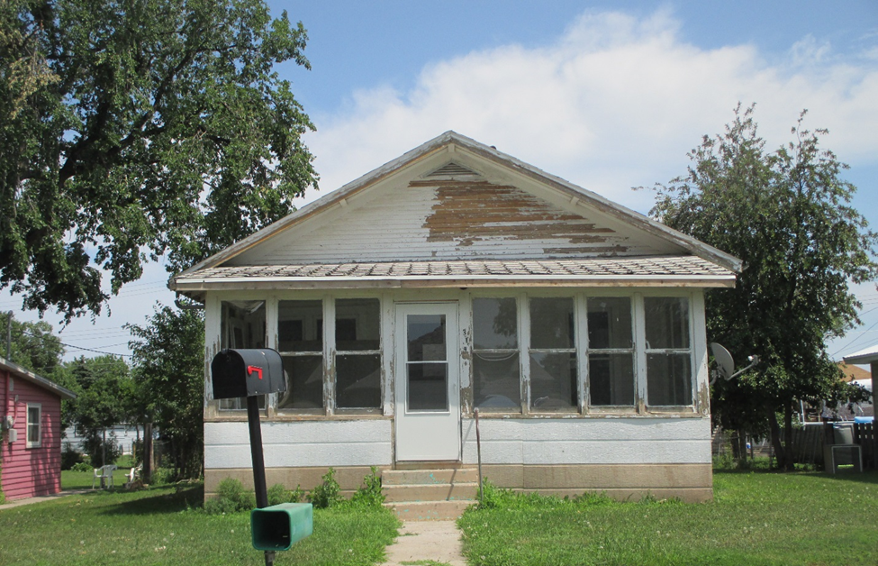
RECORD #4900

LOT SIZE 50’ X 140’ GROUND FLOOR 920 SQ FT
SINGLE FAMILY ONE STORY BASEMENT 920 SQ FT NO FINISH
FAIR QUALITY AVERAGE CONDITION 1 BEDROOM
BUILT IN 1915 1 BATH
SOLD ON 1/25/18 FOR $13,000 11’ X 12’ SOLID WALL PORCH
ASSESSED IN 2018 AT $17,380 7’ X 22’ KNEE WALL PORCH
SOLD IN 2012 FOR $12,500 12’ X 18’ DETACHED GARAGE
ASSESSED IN 2012 AT $22,360
RECORD #4900

