$82,500.00
THORSTENSON-DICKHAUT
AKASKA
AKASKA GOLDADE ADDN LOT 12 BLOCK 3
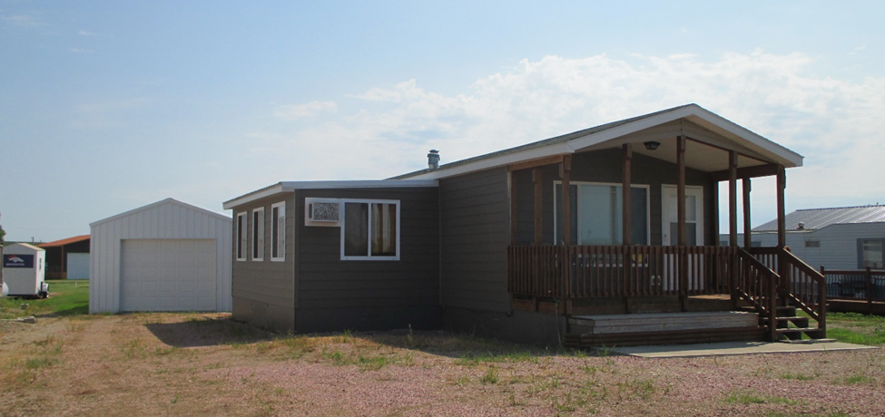
RECORD #3939

LOT SIZE 50’ X 192.74’ TOTAL LIVING 896 SQ FT
2008 16’ X 52’ HIGHLAND CLASSIC AVERAGE QUALITY
MANUFACTURED HOME AVERAGE CONDITION
2010; 14’ X 21’ ADDITION TO GARAGE 10’ X 16’ WOOD DECK
2016; SHINGLE ROOF, CENTRAL AIR 57’ X 14’ GARAGE
SOLD ON 5/30/18 FOR $82,500 10’ X 20’ ADDITION
ASSESSED IN 2018 AT $66,240
SOLD IN 2010 FOR $67,000
ASSESSED IN 2013 AT $58,170 RECORD #3939

