$272,400.00
PETERSON-PIATT
28706 127TH ST. MOBRIDGE
SW4SW4 INCLUDING LOT A & EXC LOT 1 AIRPORT 2ND SUBD. & EXC TRACT 1 PETERSON ADDN
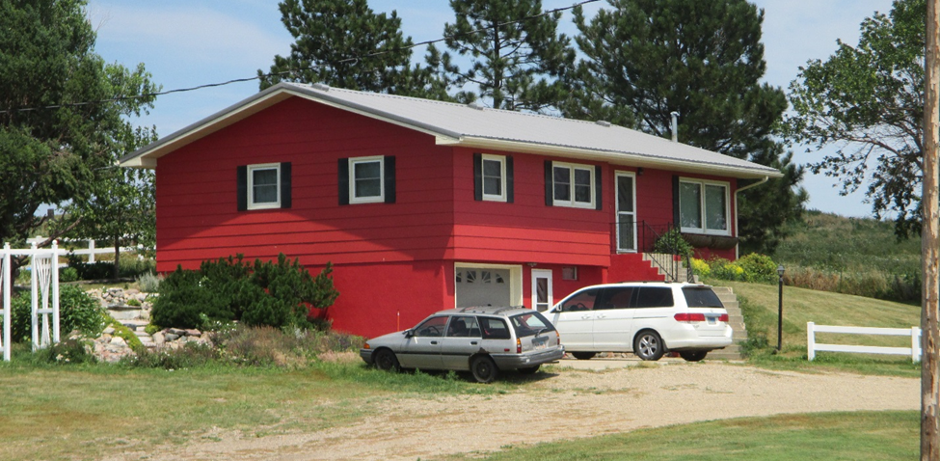
RECORD #3455

LOT SIZE 28.29 ACRES GROUND FLOOR 1264 SQ FT
SINGLE FAMILY ONE STORY 3 BEDROOMS
AVERAGE QUALITY & CONDITION 1 FULL BATH, ONE ¾ BATH
BUILT IN 1967 ONE ½ BATH
2015; TUCK UNDER GARAGE, CENTRAL AIR BASEMENT 648 SQ FT LIVING
BLOWN IN INSULATION, WOOD SHED GARAGE BUILT IN 756 SQ FT
2 GREENHOUSES, METAL WINDOWS CENTRAL AIR
SOLD ON 4/6/18 FOR $272,400
ASSESSED IN 2018 AT $275,120
ASSESSED IN 2016 AT $137,920 RECORD #3455

