$245,000.00
HOUGH-SCHLOMER
29213 HOUGH COURT, GLENHAM
TRACT 1F IN THE S2NW4, SCHLOMER ADDN, 6-123-78 TRACT1G M&M FARMS ADDN IN THE S2S2NW4 6-123-78
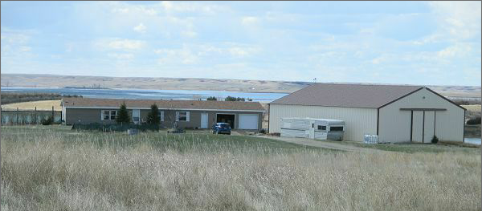
RECORD #7628

20.66 ACRES TOTAL LIVING 1680 SQ FT
MANUFACTURED HOME BASEMENT 1680 SQ FT
ONE STORY BUILT IN 2002 BASEMENT 1 BEDROOM ¾ BATH
AVERAGE QUALITY AND CONDITION 3 BEDROOMS
HEATED AND COOLED 1 ¾ BATHS
2002 NEW HOME & GARAGE 896 SQ FT ATTACHED GARAGE
2000 46’&54’ POLE BARN $15,000 192 SQ FT WOOD DECK
5’ X 7’ VINYL DECK
SOLD ON 3/24/17 FOR $245,000 BOOK 17 PAGE 188
ASSESSED IN 2017 AT $149,555
ASSESSED IN 2012 AT $130,045 RECORD # 7628

