$116,000.00
MAJESKE-STROEHL
821 3RD AVE WEST, MOBRIDGE
MOBRIDGE NWTS 1ST ADDN LOT 1 &N 20’ OF LOT 2 BLOCK 12
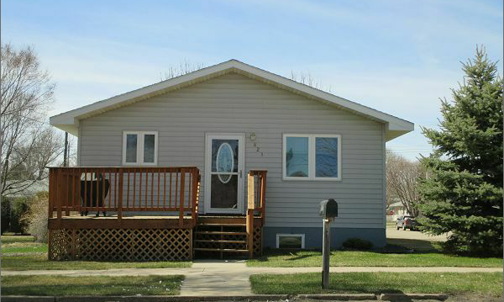
RECORD #5976

LOT SIZE 50’ X 140’ GROUND FLOOR 858 SQ FT
SINGLE FAMILY 2 BEDROOMS 1 BATH
ONE STORY BASEMENT 858 SQ FT
PLUS AVERAGE QUALITY AND CONDITION 1 BATH 500SQ FT REC
BUILT IN 1997 5 FIXTURES
CENTRAL AIR NATURAL GAS ATTACHED GARAGE 702 SQ FT
2009 NEW CABINETS,SINK,FAUCET,FLOORING WOOD DECK 165 SQ FT
NEW BATH, NEW FLOORING BASEMENT SPRINKLER SYSTEM
2010 11’ X 15’ DECK,BASEMENT BATHROOM
2015 EGRESS WINDOW, SIDING WINDOWS GOOD RECORD # 5976
SOLD ON 11/14/16 FOR $116,000
ASSESSED IN 2017 AT $114,890; 2012 AT $67,162
SOLD IN 2008 FOR $76,000; 2003 FOR $60,000

