$42,000.00
EISEMANN-WEISBECK
415 3RD AVE WEST, MOBRIDGE
MOBRIDGE GRAND CROSSING ADDITION LOT 3 BLOCK 29
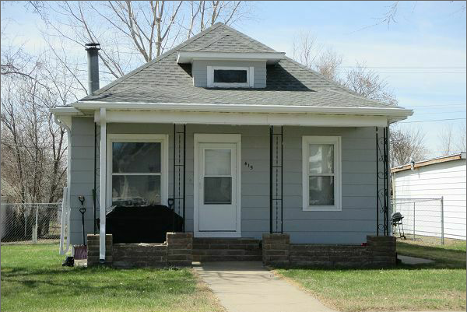
RECORD #5220

LOT SIZE 50’ X 140’ TOTAL LIVING AREA 975 SQ FT
SINGLE FAMILY BASEMENT 975 SQ FT
ONE STORY, ATTIC 1 BEDROOM 1 BATH 5 FIXTURES
AVERAGE QUALITY AND CONDITION ROOFED PORCH 161 SQ FT
BUILT IN 1930 + - DETACHED GARAGE 216 SQ FT
NATURAL GAS WINDOW AIR 2002 15’ X 140’ FENCE
2014 FOUNDATION FARE, MASONITE SIDING FARE
ALUMINUM WINDOWS POOR, ROOF GOOD
SOLD ON 12/21/16 FOR $42,000 RECORD #5220
ASSESSED IN 2017 AT $33,430
ASSESSED IN 2012 AT $24,850 SOLD IN2012 FOR $34,000

