$500,000.00
HEPPER-PRUSHA
29113 HWY 1804
TRACT 1 PHILLIPS ADDN IN SW4SW4NW4 & SW4 25-124-79
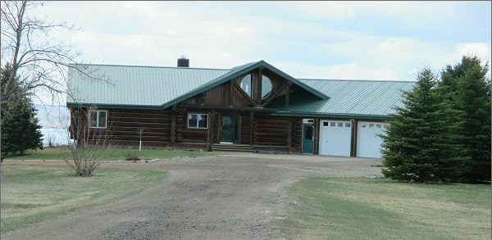
RECORD #7742

14.63 ACRES GROUND FLOOR LIVING 2807 SQ FT
SINGLE FAMILY LOG HOME BASEMENT 2807 SQ FT, 1982’ LIVING
ONE STORY 14 FIXTURES
AVERAGE QUALITY AND CONDITION FIRE PLACE
BUILT IN 2000 DETACHED GARAGE 1890 SQ FT
CENTRAL AIR ATTACHED GARAGE 784 SQ FT
FLOOR RADIANT HOT WATER
ROOFED PORCH 133 SQ FTASS
WOOD DECK 467 SQ FT
SOLD ON 3/31/17 FOR $500,000 BOOK 17 PAGE 201
ASSESSED IN 2017 AT $364,630
SOLD IN 2008 FOR $250,000 RECORD # 7742
ASSESSED IN 2012 AT $356,070

