$15,000.00
HAUSER-LAIRD
AKASKA CORRECTIVE PLAT OF LOTS 3,4,5,6 & 7
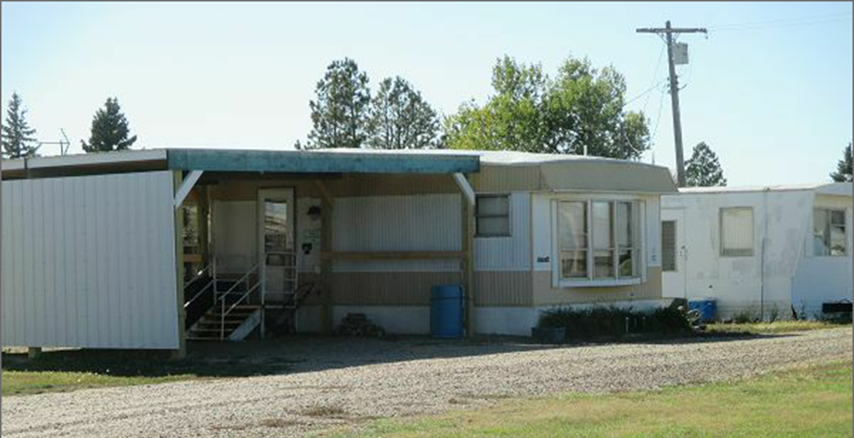
RECORD #8612

LOT SIZE 50.65’ X 180’
1979 MANUFACTURED HOME
14’ X 72’ ARTCRAFT
WARMED AND COOLED
2 BEDROOM
1 BATH
SOLD ON 5/31/17 FOR $15,000
ASSESSED IN 2017 FOR $17,050
SOLD IN 2014 FOR $7,000
ASSESSED IN 2014 AT $16,180 RECORD #8612

