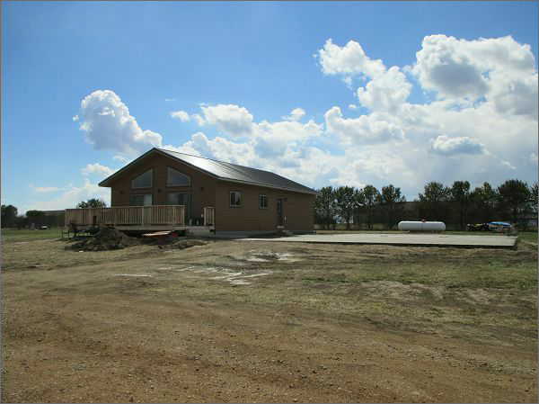
$228,000.00
RIVERVIEW HOUSING-DOUGLAS
LOT 28 NEW EVARTS 5TH ADDITION IN SW4 & SE4 29-123-78
RECORD #8437

