$260,000.00
HARE-HOWELL
54 SOUTH RIVERVIEW DR. NEW EVARTS
NEW EVARTS 3RD SUBDIVISION LOT 13, 29-123-78
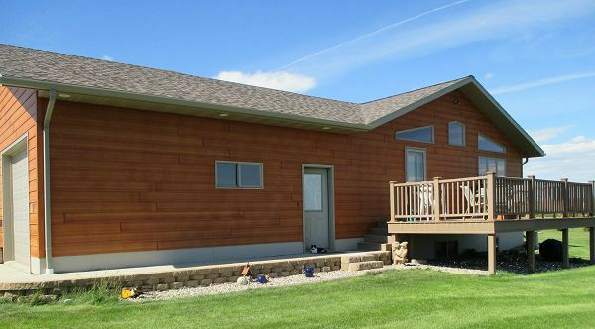
RECORD #7877

LOT SIZE 1.01 ACRES GROUND FLOOR 1456 SQ FT
SINGLE FAMILY ONE STORY 3 BEDROOMS 2 ½ BATHS
AVERAGE QUALITY & CONDITION BASEMENT 1456 SQ FT
BUILT IN 2008 1400 SQ FT FINISHED REC
2014 10’ X 12’ WOOD SHED EGRESS WINDOW EAST
2015; WOOD GRAIN SIDING ATTACHED GARAGE 728 SQ FT
WOOD DECK 10’ X 15’
CENTRAL AIR
SOLD ON 6/29/17 FOR $260,000
ASSESSED IN 2017 AT $251,800
SOLD IN 2013 FOR $230,000
ASSESSED IN 2012 AT $170,660 RECORD #7877

