$105,000.00
BAUDER-BRIDGE CITY PROPERTIES LLC
817 12TH ST WEST, MOBRIDGE
MOBRDIGE NWTS CO’S 2ND ADDN E 62.17’ OF LOTS 15 & 16 BOCK 21
RECORD #7807
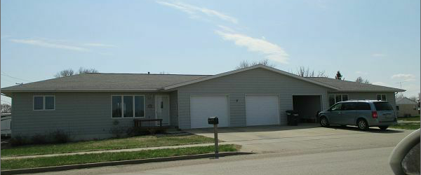
LEFT SIDE OF DUPLEX ONLY
LEFT SIDE OF DUPLEX ONLY
LOT SIZE 70’ X 92’ GROUND FLOOR 1018 SQ FT
SINGLE FAMILY 2 BEDROOMS 1 FULL BATHROOM
DUPLEX ONE STORY ADDITIONAL ¾ BATHROOM
AVERAGE QUALITY AND CONDITION BASEMENT 1018 SQ FT FINISHED
NATURAL GAS CENTRAL AIR ATTACHED GARAGE 360 SQ FT
BUILT IN 1999 6 FIXTURES
2014; SINGLE FAIR, CEMENT BOARD SIDING WOOD DECK FRONT 6’ X 8’
CASEMENT METAL-GOOD WOOD DECK REAR 6’ X 8’
SOLD ON 11/01/16 FOR $105,000
ASSESSED IN 2016 AT $124,070
SOLD IN 2006 FOR $63,500, IN 2003 FOR $75,000 RECORD #7807
ASSESSED IN 2014 AT $124,070, IN 2012 AT $90,235

