$146,000.00
KONOLD-AYOUB
714 1ST AVE WEST, MOBRIDGE
MOBRIDGE GRAND CROSSING LOTS 16 & 17B BLOCK 58
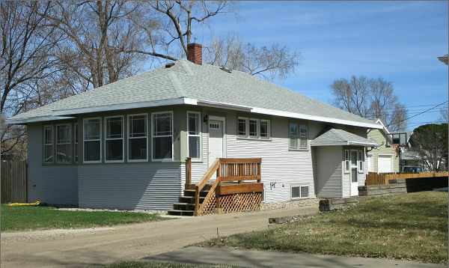
RECORD #6968

LOT SIZE 75’ X 142’ TOTAL LIVING AREA 1080 SQ FT
SINGLE FAMILY 5 BEDROOMS 1 ¾ BATH 8 FIXT.
ONE STORY BASEMENT 1080 SQ FT
AVERAGE QUALITY AND CONDITION 500 SQ FT FINISHED
BUILT IN 1950 5’ X 10’ WOOD DECK
NATURAL GAS CENTRAL AIR 30’X 32’ 2 DOOR DETACHED
45 YEAR SHINGLES AND FENCE BUILT IN 2014
NEW PAINT & STAMPED CONCRETE & APRON IN 2015 RECORD #6968
NEW BASEMENT FLOORING IN 2016
UPDATE ELECTRICAL,PLUMBING,FURNACE, WATER HEATER 2007
SOLD ON 1/25/17 FOR $146,000
ASSESSED IN 2017 AT $78,330, IN 2012 AT $30,855
SOLD IN 2013 FOR $62,000, IN 2007 FOR $78,858

