$6,500.00
MARTIN – KONOLD
006 2ND AVE WEST, GLENHAM
GLENHAM MILW LAND CO’S 1ST ADDN LOT 6 BLOCK 9
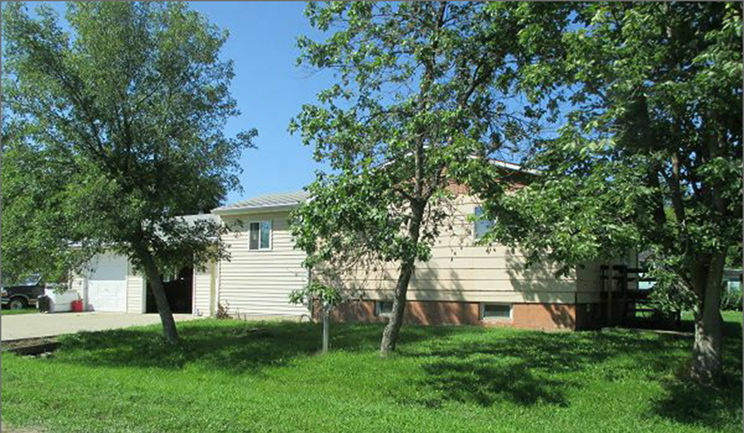
RECORD #6647
LOT SIZE 50’ X 140’ GROUND FLOOR 768 SQ FT
SINGLE FAMILY ONE STORY BASEMENT 768 SQ FT
AVERAGE QUALITY AND CONDITION ATTACHED GARAGE 960 SQ FT
BUILT IN 1975 + - SOLID WALL PORCH 72 SQ FT
1988; REMODEL WOOD DECK 80 SQ FT
NEW HOUSE ON AN OLD BASEMENT
SOLD ON 5/08/17 FOR $6,500
ASSESSED IN 2017 AT $65,460 RECORD #6647
SOLD IN 1990 FOR $17,000
ASSESSED IN 2012 AT $52,280

