$220,000.00
SCHULTZ-PATENEAUDE
1205 4TH AVE EAST, MOBRIDGE
MOBRIDGE RESURVEY OF NE4 19-124-79 LOT 4 THRU 6 & S 11’ LOT 7 OF TRACT 4
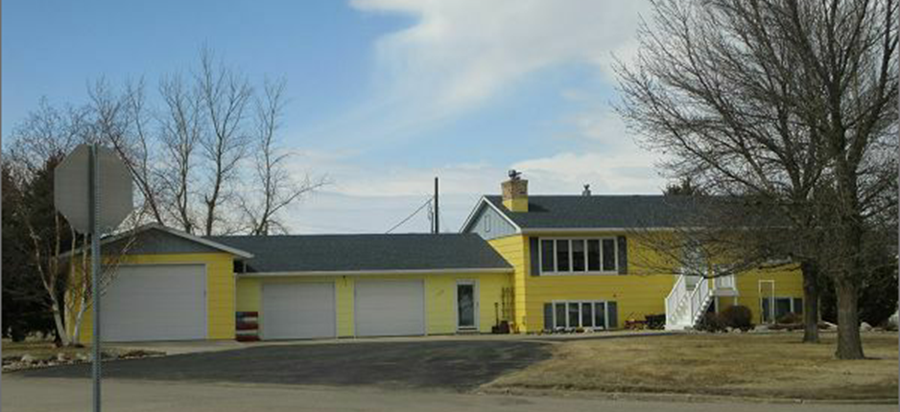
RECORD #6537

LOT SIZE 336.79 X 133’ GROUND FLOOR 1296 SQ FT
SINGLE FAMILY-BI-LEVEL FINISHED BASEMENT 1120 SQ FT
GOOD QUALITY AND CONDITION 2 BEDROOMS ABOVE 2 BELOW
BUILT IN 1977 2 FULL BATHS 1 HALF BATH
2015; ROOF GOOD, BASEMENT GOOD ATTACHED GARAGE 1372 SQ FT
WOOD BURNER IN BREEZWAY WOOD FENCE, 8X12 UTILITY SHED
SPRINKLER SYSTEM WOOD DECK 42 SQ FT
SOLD ON 3/23/18 FOR $220,000
ASSESSED IN 2017 AT $204,010
SOLD IN 2002 FOR $112,500 RECORD #6537
ASSESSED IN 2012 AT $94,605

