$139,900.00
LAWRENCE-DODD
813 8TH AVE WEST, MOBRIDGE
NWTS CO’S 3RD ADDITION LOT 3 & N 25’ OF LOT 4 BLOCK 32
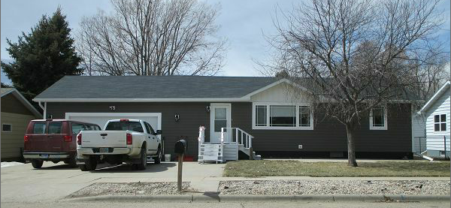
RECORD # 6152

LOT SIZE 75’ X 120’ GROUND FLOOR 920 SQ FT
SINGLE FAMILY-ONE STORY 4 BEDROOMS 2 ½ BATHS
AVERAGE QUALITY-CONDITION BASEMENT 920 SQ FT
BUILT IN 1972 670 SQ FT FIN REC
2014; SHINGLES GOOD, 2013; 2 EGRESS ATTACHED GARAGE 744 SQ FT
2016; SIDING & WINDOWS $15,000 DETACHED GARAGE 264 SQ FT
CENTRAL AIR-NATURAL GAS WOOD DECK 64 SQ FT
SOLD ON 2/21/18 FOR $139,900
ASSESSED IN 2017 AT $120,570
ASSESSED IN 2012 AT $70,095 RECORD # 6152

