$231,000.00
NELSON-VOLLER
921 10TH ST. WEST, MOBRIDGE
MOBRIDGE NWTS CO’S 3RD ADDN LOTS 11 & 12 BLOCK 29
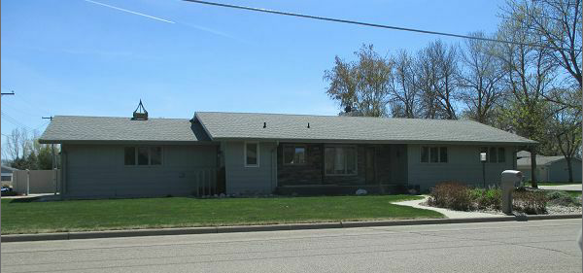
RECORD #6134

LOT SIZE 100’ X 120’ GROUND FLOOR 1588 SQ FT
SINGLE FAMILY ONE STORY 3 BEDROOMS 1 ½ BATHS
AVERAGE QUALITY AND CONDITION BASEMENT 1588 SQ FT
BUILT IN 1978 1000 SQ FT FINISHED
2014; ROOF GOOD, ROCK FACE FRONT 1 BEDROOM 1 BATH
NATURAL GAS CENTRAL AIR 10 TOTAL FIXTURES
COMPOSITE COVERED DECK FRONT ATTACHED GARAGE 766 SQ FT
EGRESS WINDOW WEST, CEMENT BOARD SIDING
1993 SPRINKLER SYSTEM, 2008 R&R FENCE $2,830
2012 ADDED 3’ TO DECK
SOLD ON 4/28/17 FOR $231,000 COVERED DECK REAR 572 SQ FT
ASSESSED IN 2016 FOR $209,510
ASSESSED IN 2012 FOR $150,260 RECORD #6134
SOLD IN 2005 FOR $142,500

