$239,000.00
HEUMILLER-SCHAFFER
1115 9TH AVE WEST, MOBRIDGE
MOBRIDGE NWTS CO’S 3RD ADDNLOTS 3, 4 & 5 BLOCK 26
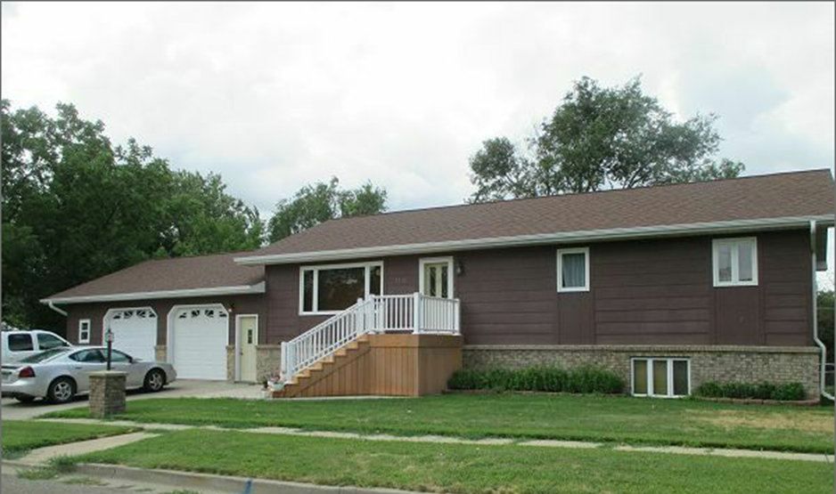
RECORD #6111

LOT SIZE 150’ X 120’ GROUND FLOOR 1400 SQ FT
SINGLE FAMILY ONE STORY 3 BEDROOMS 2 BATHS
BUILT IN 1969 BASEMENT 1400 SQ FT
AVERAGE QUALITY AND CONDITION 2 BEDROOMS BELOW
2014; SHINGLES GOOD, SPLIT LEVEL ATTACHED GARAGE 896 SQ FT
BRICK FACE ALL AROUND LOWER WALL RAISED WOOD DECK 572 SQ FT
MASONITE SIDING, LARGE BUMP OUT WINDOW CENTRAL AIR
SLAB PATIO COVERED BY BI-LEVEL WOOD DECK FRONT DECK/STAIRS 88 SQ FT
CASEMENT/WOOD WINDOWS FAIR
SOLD ON 7/13/17 FOR $239,000 BOOK 17 PAGE 505
ASSESSED IN 2017 AT $201,150
SOLD IN 1995 FOR $87,000 BOOK 95 PAGE 566
ASSESSED IN 2012 AT $87,715 RECORD #6111

