$120,000.00
WIEST-HARE
812 8TH AVE WEST
MOBRIDGE NWTS CO’S 2ND ADDN N 17’ OF LOT 10 & ALL OF LOT 11 BLOCK 24
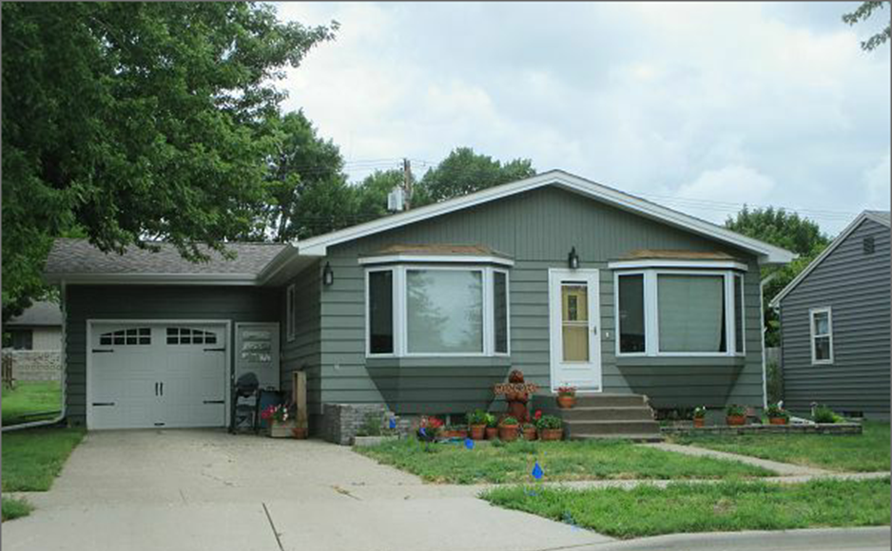
RECORD #6096
LOT SIZE 60’ X 140’ GROUND FLOOR 1092 SQ FT
SINGLE FAMILY 3 BEDROOMS 2 BATHS
ONE STORY BASEMENT 1092 SQ FT, 819’ FIN. REC.
AVAERAGE QUALITY & CONDITION ATTACHED GARAGE 336 SQ FT
BUILT IN 1970 WOOD DECK 240 SQ FT
2014; SHINGLES GOOD, 2 BAY WINDOWS 8’ X 10’ ATTACHED SHED
BLOCK FOUNDATION, NEWER WINDOWS
CENTRAL AIR, NATURAL GAS
ALUMINUM/VINYL WINDOWS GOOD RECORD # 6096
SOLD ON 7/21/17 FOR $120,000
ASSESSED IN 2017 AT $120,950
SOLD IN 2007 FOR $54,600; ASSESSED IN 2012 AT $57,125

