$15,000.00
HAUSAUER-GISI
1102 7TH AVE WEST, MOBRIDGE
MOBRIDGE NWTS CO’S 2ND ADDN LOT 9 & S 8’ OF LOT 10 BLOCK 20
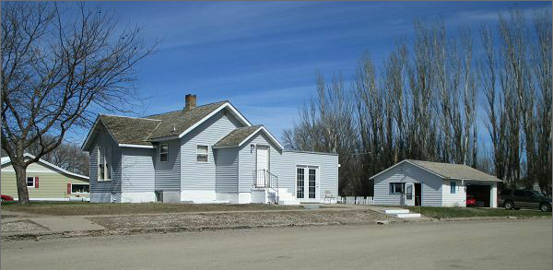
RECORD # 6060

LOT SIZE 54’ X 140’ LIVING AREA 1050 SQ FT
SINGLE FAMILY 2 BEDROOMS 1 BATH
AVERAGE QUALITY AND CONDITION BASEMENT 1050 SQ FT
BUILT IN 1940 + - DETACHED GARAGE 682 SQ FT
HEATED CENTRAL AIR OPEN SLAB PORCH 276 SQ FT
2014; ROOF SHAKES POOR, LAP SIDING FAIR
ALUMINUM WINDOWS FAIR
DETACHED GARAGE SIDING FAIR, ROOF POOR
SOLD ON 11/21/16 FOR $15,000
ASSESSED IN 2016 AT $57,720
SOLD IN 2012 FOR $21,750 RECORD #6060
ASSESSED IN 2012 AT $23,545

