$105,000.00
ERDMAN-HESS
1111 6TH AVE WEST, MOBRIDGE
MOBRIDGE NWTS CO’S 2ND ADDN S 6’ OF LOT 3 & ALL LOTS 4 & 5 & N 22’ OF LOT 6 BLOCK 20
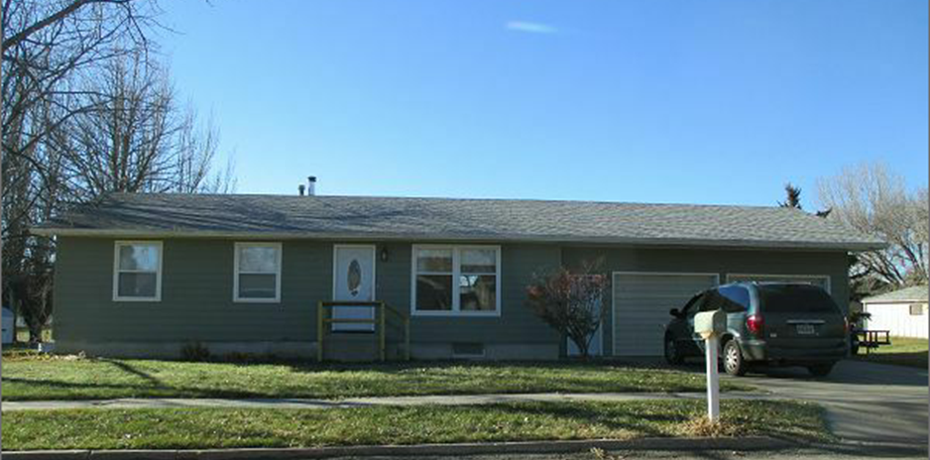
RECORD # 6057

LOT SIZE 120’ X 140’ GROUND FLOUR 1040 SQ FT
SINGLE FAMILY ONE STORY 2 BEDROOMS 1 BATH ABOVE
AVERAGE CONDITION & QUALITY BASEMENT 1040 SQ FT
BUILT IN 1978 312 SQ FT FINISHED REC.
2015; ROOF GOOD, POURED FOUNDATION
VINYL SIDING POOR, NATURAL GAS 1 BEDROOM 1 BATH BELOW
ALUMINUM/WOOD WINDOWS POOR ATTACHED GARAGE 624 SQ FT
SOLD ON 7/20/17 FOR $105,000
ASSESSED IN 2017 AT $89,830
SOLD IN 2013 FOR $55,000 RECORD #6057
ASSESSED IN 2012 AT $37,635

